DevOps-Deploy Environment with ORM Stack

Contents

1. Introduction 3
2. Workflow diagram to deploy the stack 3
3. Create stack for the Devops-Deploy Environment 4
4. Plan the Job 7

Introduction
A reference to the compute resources to which artifacts are deployed. An environment can be a reference to a Function application, a group of Compute instances, or a Container Engine for Kubernetes (OKE) cluster.
. Before create references to a target environment, user must perform the following tasks:
- Create a target environment supported by DevOps, if it doesn’t exist in the Oracle Cloud Console.
- Supported environments are Container Engine for Kubernetes clusters, compute instances (Oracle Linux and CentOS only), and Function applications.
- Create a DevOps project.
The DevOps service creates references based on the selected target environment. For instructions, see the following topics:
- Creating a Kubernetes Cluster Environment
- Creating a Functions Environment
- Creating a Compute Instance Group Environment

Workflow diagram to deploy the stack
Below diagram shows how the Terraform Artifact are applied in the OCI. While creating a ORM stack, using terraform deliverables Init, Plan and Apply is the flow to provision the resource in the OCI. We can have the deliverables in any of below.
- GitLab/GitHub Repo
- Bitbucket
- Can be in folder/.zip in the local disk
- Object Storage Bucket
- Can be in compartment
- Oracle provided Template


Create stack for the Devops-Deploy Environment

Go to OCI Console Developer Services Resource Manager Stacks select the compartment Create Stack

My Configuration Folder Browse Select the “DevOps-Deploy Environment” folder that contains the terraform Upload

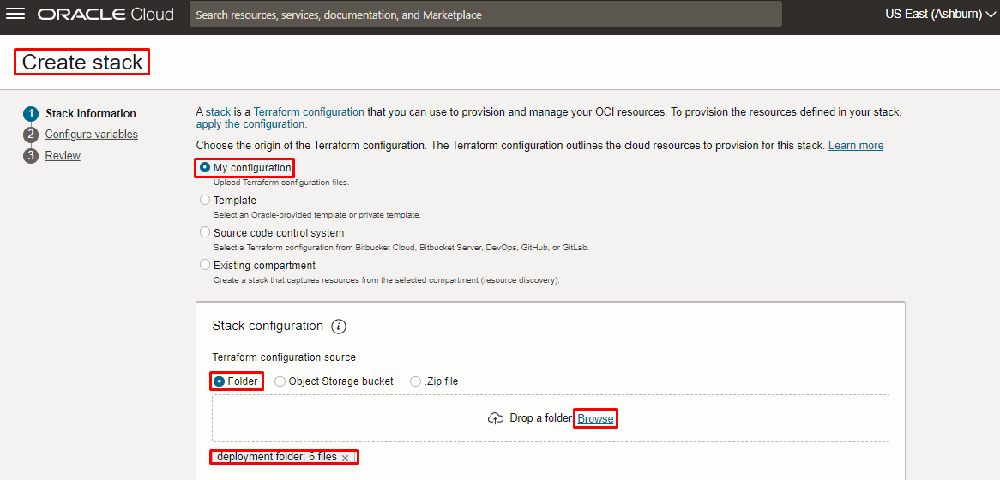

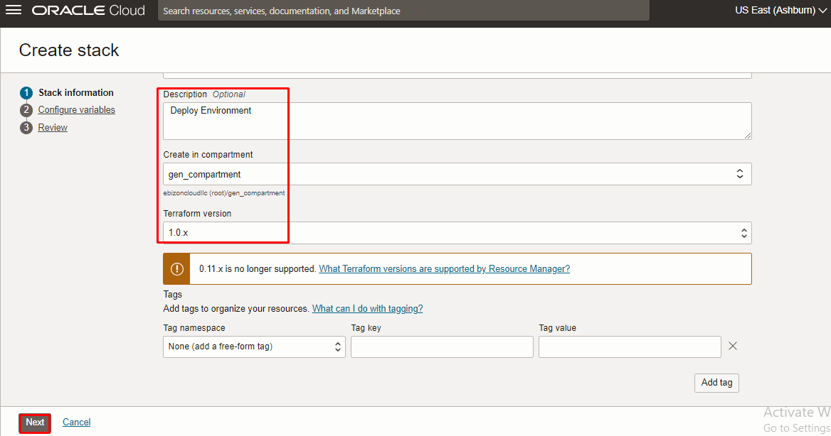

Click “NEXT”

Select the parameters as per the below screen,

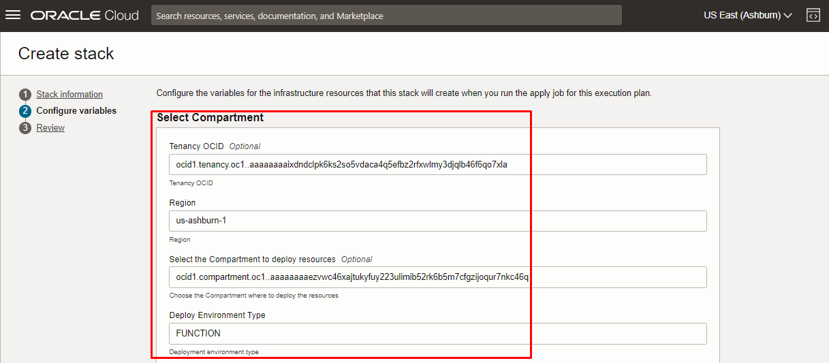

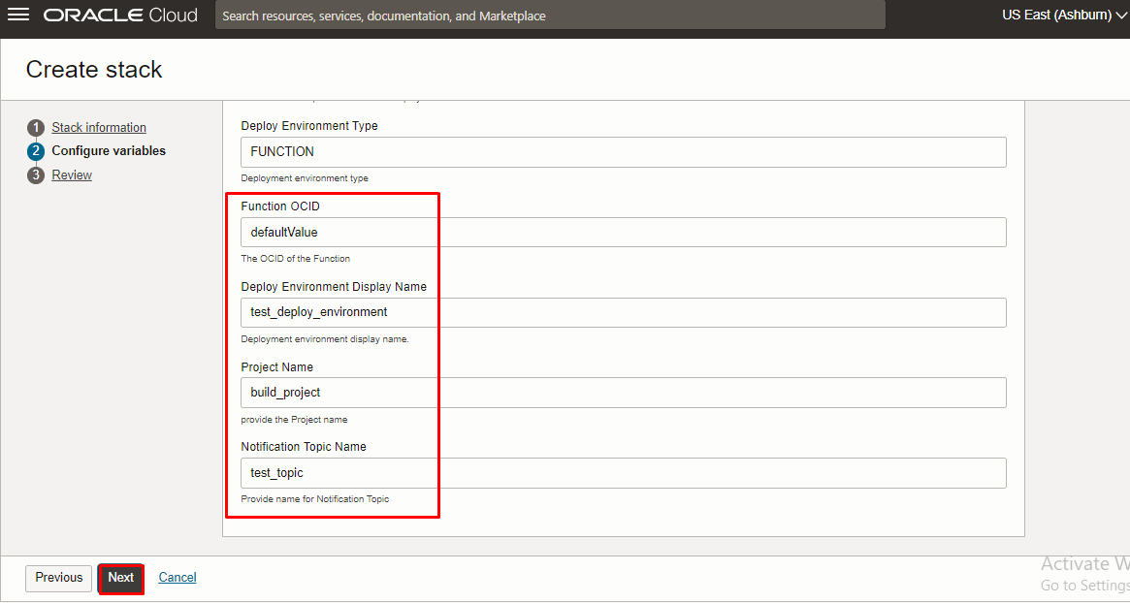

Click “NEXT” Click “CREATE”

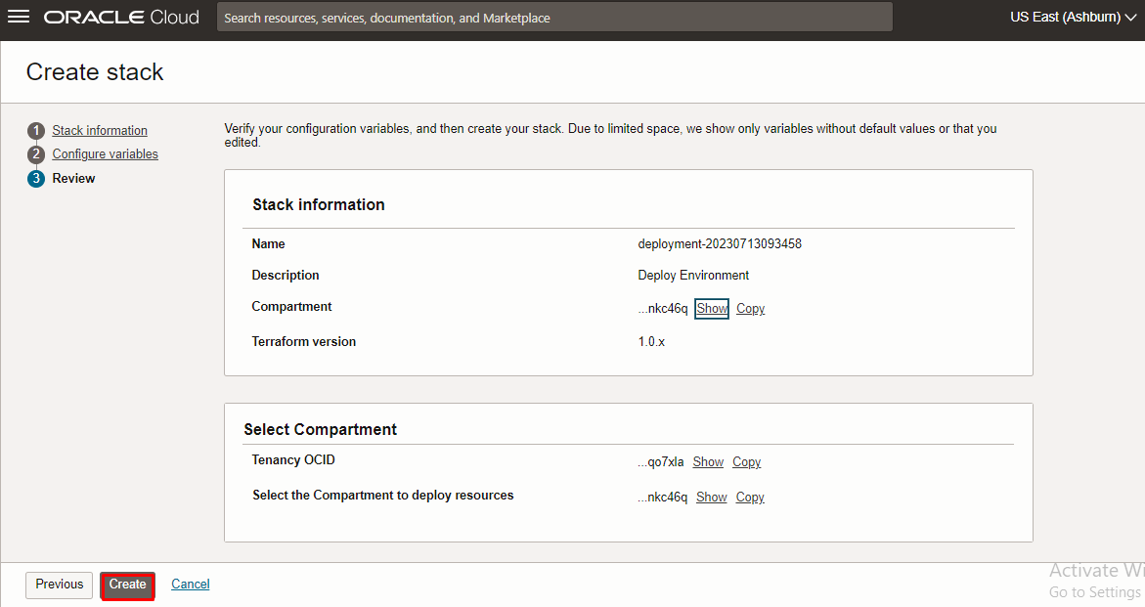

Plan the Job

Click the “Plan”

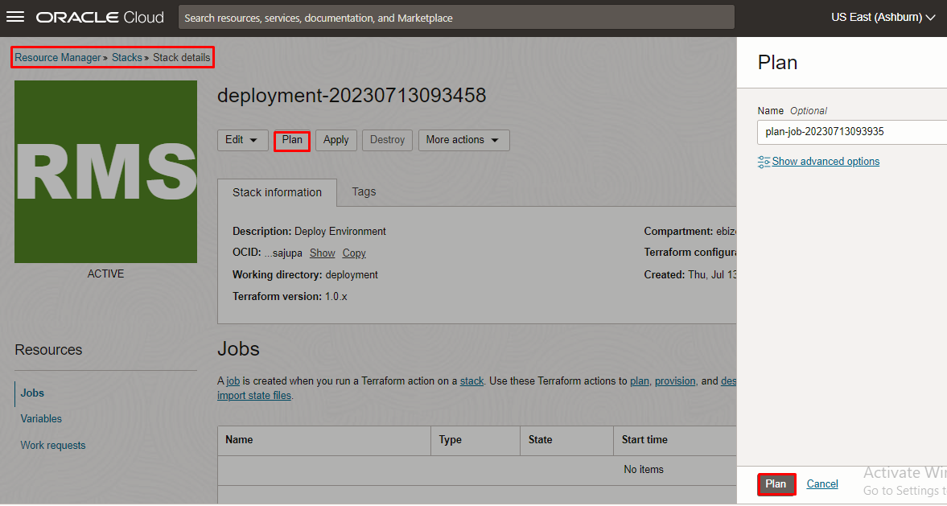

Verify the Plan is successful.

